# **SOFTWARE REQUIREMENT DOCUMENT FOR GROUP 1.**

# **ELECTRONIC VOTING SYSTEM.**

**BASIC REQUIREMENTS:**

* This software should be able to provide a user-friendly interface that is simple, and easy to use.
* This software should allow a user to safely deliver a vote for at most one candidate in an election.
* This software should allow an administrator to view total votes of any individual or group participating in an election.

**OVERALL OVERVIEW OF FUNCTIONS REQUIRED BY STUDENT AND ADMINISTRATIVE USAGE:**

***STUDENT VOTER:***

* Every student should be able to securely login into the system using a provided one-time pass code which will be generated and given to them. This one pass code becomes obsolete after a single voting process is confirmed successful.
* There should be a simple user-interface after the student has successfully logged in which will provide the list of competing candidates to the student to select from. This page should have a subsequent confirm button which will finally feed the count system with the student’s selection after being clicked.
* After the confirmation is done, a simple feedback page should show that the voting process has been successfully completed.

***ADMINISTRATOR:***

* There should be a selection point to allow login for administrative access.
* After an administrator has successfully logged in, he/she should then come to a simple easy to comprehend page to read final results after voting is completed.

**DESCRIPTION OF REQUIREMENTS USING THE USE-CASES APPROACH.**

## ***USE-CASE DIAGRAM***

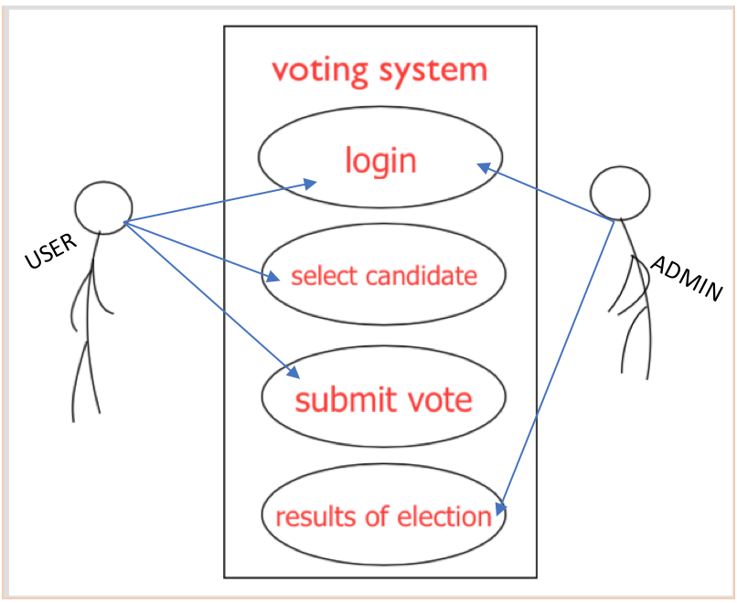

|  |  |  |  |  |  |  |  |  |
| --- | --- | --- | --- | --- | --- | --- | --- | --- |
| |  |  | | --- | --- | | FUNCTION: | SCENARIOS: | | LOGIN: | 1. The first page a voter encounters is the login page where he is required to enter the a his/ her student ID together with a provided passcode to be able to access the candidate selection page. | | SELECT CANDIDATE: | 2. Upon successfully login in, a user is taken to the core part of the program which is the part where a candidate may select the candidate of choice and submit vote. | | SUBMIT VOTE: | 3. After voter has selected the candidate of choice the voter is directed to click on a submit button at the base of the same page candidates are displayed for selection. After the submit button is click the choice is processed as increment to the selected candidate. |   **USER:** |

|  |  |  |  |  |  |  |
| --- | --- | --- | --- | --- | --- | --- |
| **ADMINISTRATOR:**   |  |  | | --- | --- | | FUNCTIONS: | SCENARIOS: | | LOGIN: | 1. Just like the voter the administrator also enters a passcode and a user ID but also has to check the administrator box beside the user ID pane to be able to access the administrative page with his/her details. | | ELECTION RESULT PAGE: | 2. After successfully login in as an administrator the current user is shown the administrator’s page where the final results can be viewed for all candidates in the contest. | |

|  |  |  |  |  |
| --- | --- | --- | --- | --- |
| **EXCEPTION HANDLING:**   |  |  | | --- | --- | | LOGIN: | 1. In the case that any user inputs wrong account details, a notice will be shown that will indicate the section the user has to correct. | | CANDIDATE SELECTION PAGE: | 2. When a user (voter) clicks the submit button on this page without selecting any candidate the user is prompted via a text notice so select one candidate before submitting vote. | |

**ACTIVITY DIAGRAM**

|  |
| --- |
| ../Desktop/Screen%20Shot%202017-10-31%20at%2014.18.30.png |

**CONCLUSION:**

The overall look and interaction of this application should be very simple straightforward and easy-to-use. In light of this, any user should require close to no assistance whilst using this voting system.